

Travlr Getaways

CS 465 Project Software Design Document
Version 1.3

Table of Contents

CS 465 Project Software Design Document 1
Table of Contents 2
Document Revision History 2
Instructions 2
Executive Summary 3
Design Constraints 3
System Architecture View 3
Component Diagram 3
Sequence Diagram 4
Class Diagram 4
API Endpoints 4
The User Interface 4

Document Revision History

Version | Date | Author | Comments
1.1 | 01/26/25 | Fernando Lomeli | Changes have been made to the executive summary, design constraints, and system architecture view: component diagram sections.
1.2 | 2/12/25 | Fernando Lomeli | Added sequence and class diagrams. Updated the API Endpoints table.
1.3 | 2/20/25 | Fernando Lomeli | Updated the API endpoints table and changes have been made to the user interface section along with screenshots of the application.

Instructions

Fill in all bracketed information on page one (the cover page), in the Document Revision History table, and below each header. Under each header, remove the bracketed prompt and write your own paragraph response covering the indicated information.

Executive Summary

The appropriate architecture for the web application, Travlr Getaways, based on the client’s software requirements for a customer-facing side of the application and an administrator single-page application (SPA) will involve the use of a model view controller (MVC) framework.

The web application development of Travlr Getaways will use the MEAN stack which stands for MongoDB, Express, Angular, and Node.js. This customer-facing web application runs on Node.js which is a cross-platform JavaScript runtime environment. The Express framework is useful for managing the connection between Node.js and MongoDB, allows the use of routes, and handles HTTP requests/responses more easily. MongoDB is a NoSQL database useful for storing JSON data and rendering it with a Handlebars (HBS) templating engine. Angular is then used to develop the administrator single-page application with admin features making maintenance easier. This should allow the admin to overview the database and add, delete, or update trips.

Design Constraints

There are a few design constraints that come with developing the web-based Travlr Getaways application when using the MEAN stack. One of the design constraints includes its learning curve and lack of widespread support. There is a lack of experts in this framework and the learning curve is difficult making it tough to find qualified team members to join the team. Another design constraint includes security vulnerabilities as the MEAN stack does not follow OWASP’s top ten list of vulnerabilities. This makes it tougher to defend against unauthorized users or hackers and protect data. There can also be some performance constraints that arise. One issue is that the MEAN stack does not perform the best on mobile devices. Performance may also be affected with complex data binding or when handling high intensity dynamic content.

System Architecture View

Component Diagram

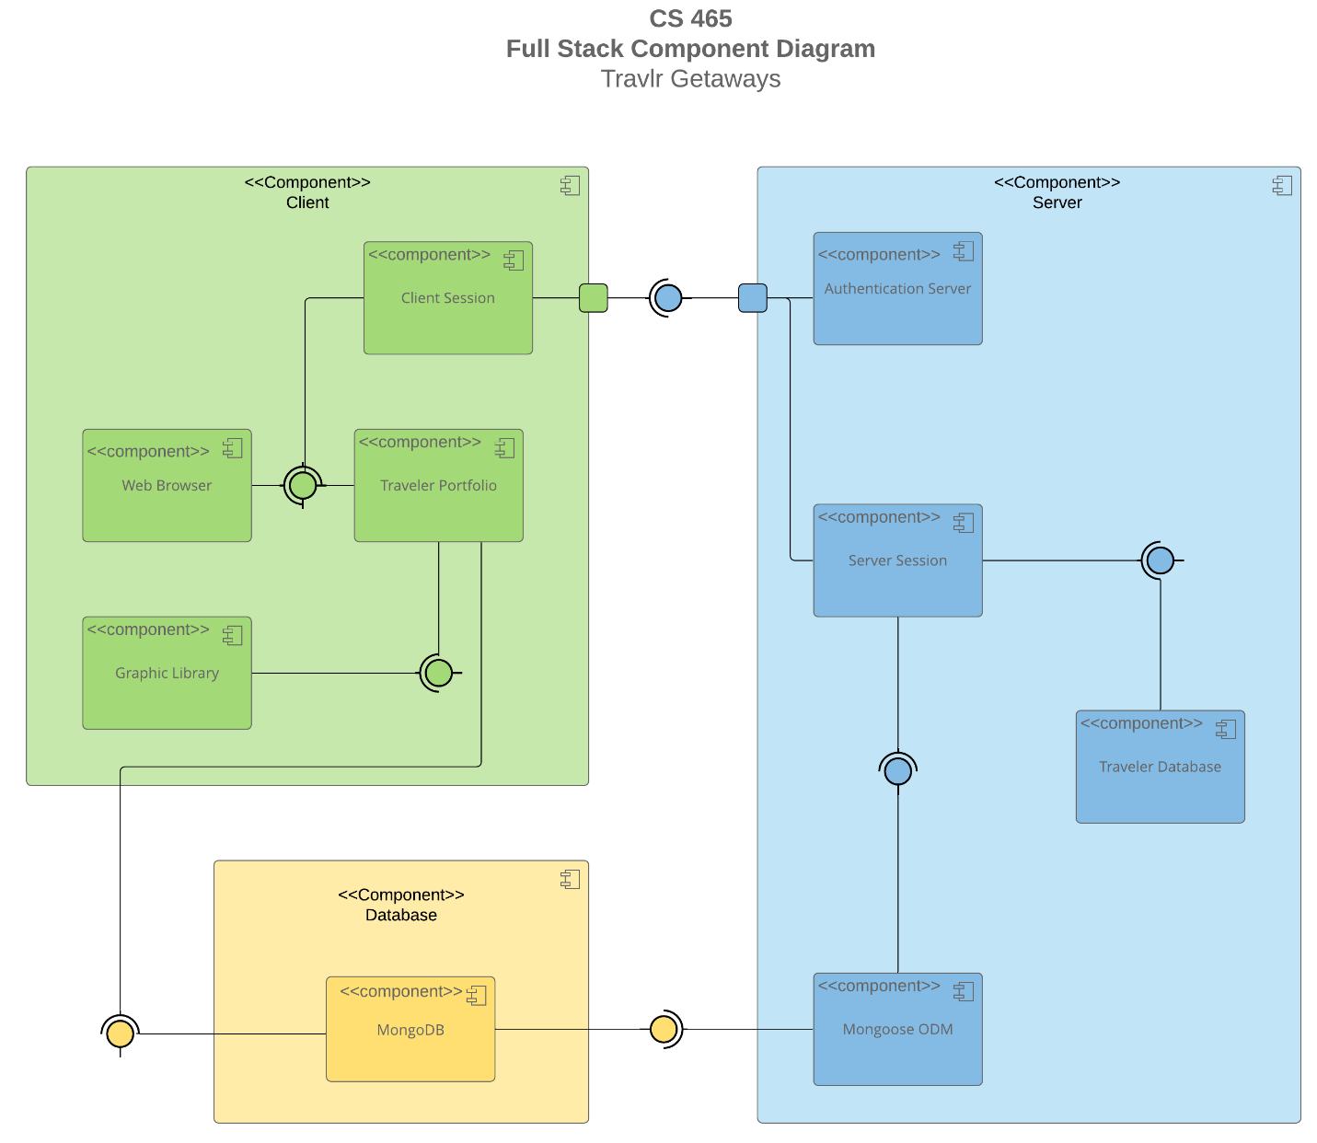

The overall system architecture of the Travlr Getaways web application includes three components or tiers known as the client component, server component, and database component. Since these components are separate, they can be scaled independently if needed. This three-tier architecture is also secure as the client does not directly access the data. All communication goes through the server component as it collects and process information from the client component which then stores and manages that information in the database component.

The client component is made up of the client session, the web browser, the Travlr portfolio, and the graphic library. The server component is made up of the authentication server, the server session, Travlr database, and Mongoose ODM. The graphic library and Travlr portfolio contain static/dynamic content to provide to the web browser which provides the user interface. The client session is for an individual client that goes through the authentication server and then communicates within a server session. Server sessions can host multiple clients. Mongoose ODM is used to configure MongoDB, manage the relationships between data, and provides an interface to alter the database. The database component contains MongoDB which contains the data to be displayed to the web browser and has a flexible data modeling system making it easy to alter or organize data.

Sequence Diagram

The Travlr Getaways sequence diagram begins with an actor or user accessing the client-side of the website with Angular. The actor enters a route into the browser which takes the route and interacts with the correct controller. The controller makes a call to the HTTP Client to retrieve data. The HTTP Client connects to the server-side and the model accesses the required information from MongoDB through Mongoose ODM. The database processes the request and sends back the data to the front-end/client-side HTTP Client. These results get sent back through the controller to display the appropriate view in the browser for the actor/user.

Class Diagram

This Travlr Getaways class diagram displays the classes of this web application. Beggining with the MemberAccount class, we have attributes such as membernumber, memberstatus, and memberclub. Membership_Admin class has an aggregation relationship with MemberAccount as a member can have an account without being an admin. TravellerInfo inherits from MemberAccount and introduces a new attribute companionnum as an integer type. The Travel_Agent class contains methods to book a package, flight, hotel, or cruise. Travel_Agent has a multiplicity of 0 to many with the HotelBooking, FlightBooking, and CruiseBooking classes which also contain a multiplicity of 0 to many. This means that there could be 0 or more travel agents that have booked 0 or more trips. All of the booking classes also obtain data from the TravellerInfo class. The HotelBooking, FlightBooking, and CruiseBooking also have a relationship and obtain data from the HotelInfo, FlightInfo, and CruiseInfo classes respectively. The Cruise, Flight, and Hotel Info classes inherit from the superclass TripInfo which contains attributes like destination and dates. Cruise, Flight, and Hotel Info classes all have an aggregation relationship with the Itinerary class as an itinerary would include the data from all those classes like the flight and hotel information.

API Endpoints

Method | Purpose | URL | Notes
GET | Retrieve list of trips | /api/trips | Returns all active trips from the database
GET | Retrieve a single trip | /api/trips/:tripcode | Returns a single trip instance, identified by the trip code passed on the request URL
POST | Adds a single trip | /api/trips | Adds a trip to the database
PUT | Updates a single trip | /api/trips/:tripcode | Updates a single trip to the database
POST | Registers a new user | /api/register | Registers a new user to the database with a name, email, and password. Returns a JWT token.
POST | Allows a user to login | /api/login | Authenticates/login a user with an email and password.

The User Interface

Figure 1: Displays page while being logged out. Figure 2: Displays the login page

Figure 3: Displays page while being logged in. Figure 4: Displays edit trip page

Figure 5: Displays the updated trip. Figure 6: Displays a unique trip being added.

Figure 7: Displays new trip.

Angular Project Structure and SPA Summary

Angular is a powerful front-end framework that handles the client side while Express is a minimal framework that handles the backend. These two frameworks are similar in some ways such as how they both essentially used a model view controller structure. Angular supports the separation of concerns and separates the application logic from the user interface layer. This makes Angular more organized since it is component based. Angular also uses two-way data binding to allow components in the application to share data. This allows synchronization between the model and view.

The front-end single-page application (SPA) was built using Angular. As opposed to a simple web application interaction, an SPA loads a single page and obtains data from the web server to rewrite the page with the new content rather than loading a new page. There are some advantages and disadvantages that come from SPA functionality. A single-page application is beneficial in that it improves the user experience by being fast and responsive. One reason for this is that it loads a minor JSON file rather than loading a new page when updating content. It also leads to smooth transitions and fast navigations because the webpage does not need to refresh as only the required data is transmitted. A disadvantage of using an SPA is when hitting the back button, it removes them from the site or causes a server request with changes to the visible data. Another drawback is compromised search engine optimization with most search engines and the slower initial load times.

The process of testing to make sure the SPA is working with the API to GET and PUT data in the database involves using Postman, a lightweight API client, to test the calls functionality. The data gets received in the response. One may even check the database with DBeaver or MongoDB Compass to ensure the calls worked. When using the calls on the webpage, they should also allow the updating of a new trip and receive and load that data onto the webpage along with the database. Angular also includes some built-in testing utilities.

